Bài tập
Phần 1: Search
1. This problem considers three search methods applied to a state space that is a tree, where the problem is to find a path from start state S to goal state G. All arcs are directed, from the higher node to the lower node in the figures below.
- Depth-First Iterative Deepening. Expand children left to right. Write beside a node the number or numbers indicating when that node is expanded or the goal test performed, starting from 1.
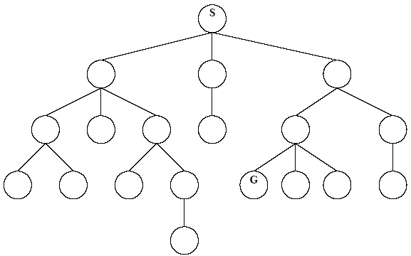
- Uniform-Cost Search. Each arc is labeled with the associated operator cost. For each node expanded or the goal test performed, write down the number indicating when it was expanded, starting from 1. Also, for each node inserted in the NODES list, write its g value next to the node. Do not write the g value for nodes that are never inserted into the NODES list.
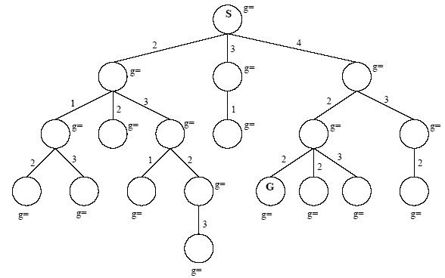
- A* Search. Each arc indicates the operator cost, and each node’s heuristic function value is indicated beside it. For each node expanded or the goal test performed, write down the number indicating when it was expanded. Also, for each node inserted in the NODES list, write its f value next to the node. Do not write the f value for nodes that are never inserted into the NODES list.
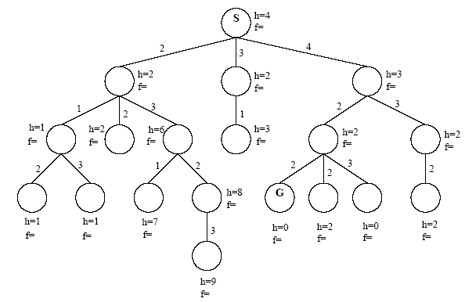

Phần 2: Game
1. Alpha-Beta Search
Consider the following game tree in which the static evaluation function values are shown below each leaf node. Assume that the root node corresponds to the maximizing player. Assume the search visits children left to right.
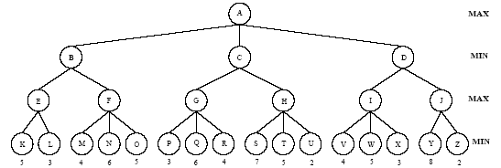
- What move would the MINIMAX algorithm choose, and what is the backed-up value of that move?
- What nodes are not examined when α-β pruning is done?
- (c) Suppose we use α-β pruning to search a game tree and decide that some successors of node n can be pruned. Later in the traversal of the game tree we encounter the same state (i.e., board position and player who’s turn it is to move) at different node m which is at the same level as n. Can we immediately prune the same successors of m from our search tree? Explain why briefly.

